Refer -   
  
<https://medium.com/@sumindaniro/use-azure-devops-to-deploy-an-azure-sql-database-2c79570829cf>  
  
SQL Source control - visual studio

Open visual studio 2022

Clone repo, you can get the URL from below

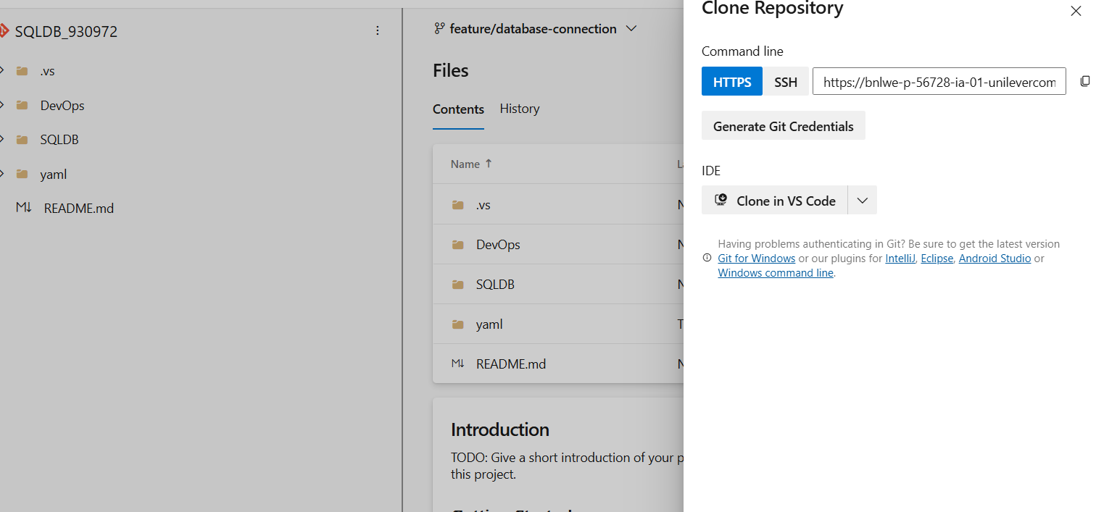

Give the url and local repo location

Then it will show like this

Connect to azure SQL database  
  
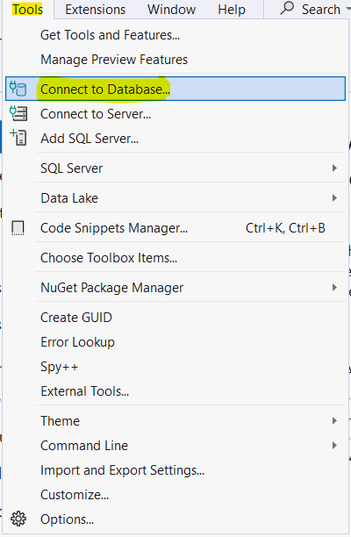

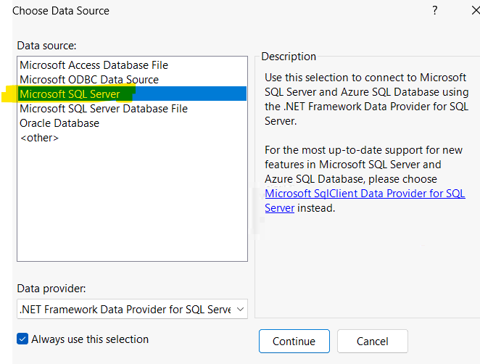

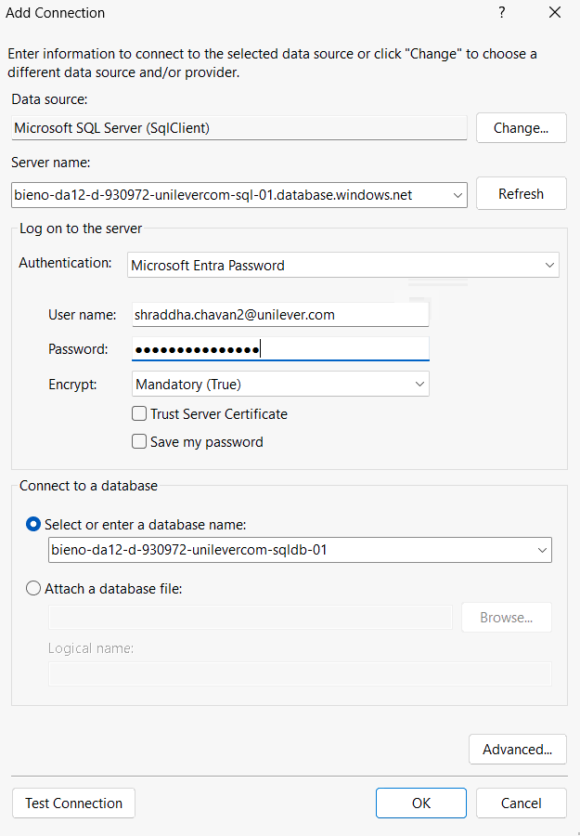

Click on test connection. It will show you this.

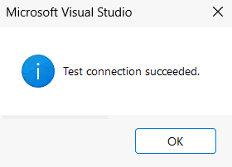

Then click “ok” to connect.

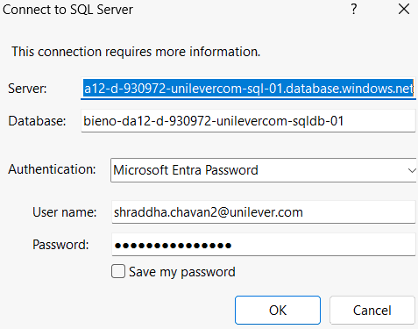

Now again click ok.   
Check server explorer, it will show database connection and the details of database

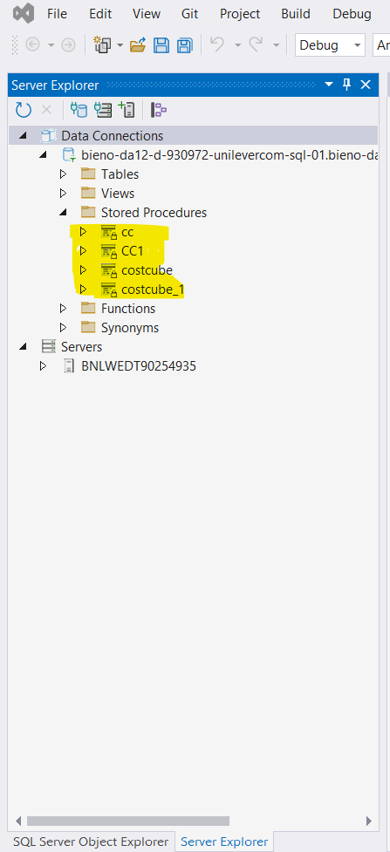

Once DB is connected go to solution explorer and right click on solution - demo

